Coordination and Subordination

- Divide with a Period (two simple sentences)
- I like cake. I like ice cream.

- Combine with a Semicolon (two simple sentences)
- I like cake; I like ice cream.
- I like ice cream; she does not.

- Conjunctive Adverbs and Phrases (two simple sentences)
- I like cake. On the other hand, I hate ice cream.
- I like cake. Also, I love ice cream.
- I can always tell who likes me. However, I never know who hates me.

- Coordinating Conjunctions (compound sentence)
- I like cake, and I like ice cream.
- I can always tell who likes me, but I never know who hates me.

- Subordination and Subordinating Conjunctions (complex sentence)
- When it rains, it pours.
- It pours when it rains.
- I feel like you should be doing better because you are such a hard worker.
- Because you are such a hard worker, I feel like you should be doing better.

- Combine with a Colon (two simple sentences) – only in specific situations
- My mother has a saying: always be yourself.
- Bob expressed his feelings about ice cream: “It’s just disgusting.”

Identifying Sentence Connectors
Coordinating Conjunctions – Compound Sentences
- Have the acronym FANBOYS (For, And, Nor, But, Or, Yet, So)
  - “For” is an old fashioned form – “I wept, for he was dead.”
  - “For” and “Yet” have alternate uses
    - “For” as a preposition – “I bought a rose for Oswald.”
    - “Yet” as an adverb – “Oswald has not seen it yet.”
Subordinating Conjunctions – Complex Sentences
- There are so many – no way to memorize
  - Because, If, While, Although, When, Even if, Even though, Whereas
- Pass the “Flip” test.
  - Flip Test
    - Original Sentence: I wear a coat when it is cold.
    - Flipped Sentence: When it is cold, I wear a coat.
  - Subordinating Conjunctions CAN be flipped. Other connectors cannot.
- Many can be prepositions in other places in a sentence
  - Until, Before, After
Conjunctive Adverbs – Link Two Simple Sentences
- There are tons and tons, frequently coining new ones, come in multi-word phrases
  - However, Also, Thus, Therefore, In contrast, Despite this, Similarly,
- Work VERY similar to FANBOYS. Memorize FANBOYS.
- IF it is a) not on FANBOYS and b) fails the flip test THEN it is a Conjunctive Adverb.
- As Adverbs they are also Adverbials
Combinations
They can be combined together! The second sentence is “compound complex.”
I like ice cream. However, I hate cake, and I only like pie when I am camping.

Punctuating Connected Sentences
(most official prescriptive rules)
Coordinating Conjunctions
- Add a comma before the coordinating conjunction.
  - Correct: “I like ice cream, and I like cake.”
  - Incorrect: “I like ice cream. And, I like cake.”
Subordinating Conjunctions
- Has two forms depending on how it is “flipped”
  - Dependent Clause Second – No Comma
    - I like pie when I go camping.
  - Dependent Clause First – Add a Comma
    - When I go camping, I like pie.
Conjunctive Adverbs
- Add a comma after the Conjunctive Adverb
  - Correct: I like ice cream. However, I do not like cake.
  - Incorrect: I like ice cream, however, I do not like cake.
Colons and Semicolons
- First letter after a colon or semicolon is lower case, unless it’s a proper noun.
  - Correct: They won the game; he scored a goal.
  - Incorrect: Correct: They won the game; He scored a goal.

- Coordination of Phrases

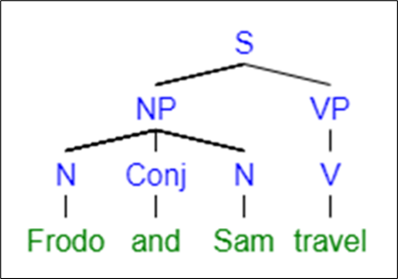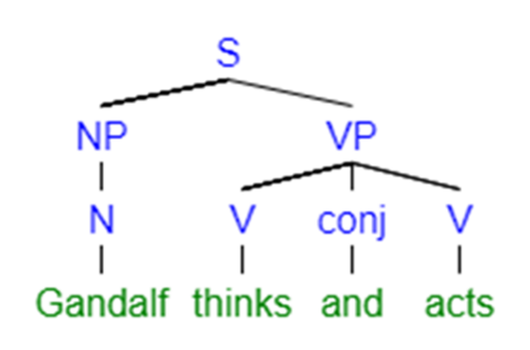
- Coordination of Clauses (coordinating conjunction)
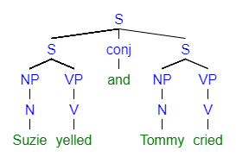
- Subordination
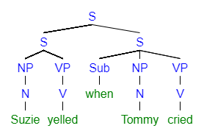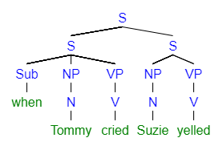
- Conjunctive Adverbs and Connecting Phrases

